Day 10

SQL Basics – SELECT, INSERT, UPDATE, DELETE
TASK:
1.CREATE database company_db;
2.create table department(dept_id int primary key, dep_name varchar(50),
location varchar(20));
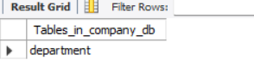
3.describe table department;
4. insert into department(dept_id,dep_name,location)values(1,'HR','bengaluru'),
(2,'IT','hydrabad'), (3,'finance','mumbai’),(4,'marketing','mumbai');
5. select * from department;
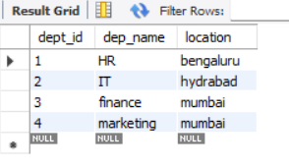

6. create table employees(emp_id int primary key,name varchar(20),age int,gender char(1),salary decimal(10,2),
dept_id int,hiredate date,foreign key(dept_id) references department(dept_id));
7. insert into employees(emp_id,name,age,gender,salary,dept_id,hiredate)values
(101,'Arjun',28,'M',45000,2,'2020-05-10'),(102,'Priya',31,'F',52000,1,'2019-03-15'),
(103,'Karthick',26,'M',40000,2,'2021-07-22'),(104,'Divya',29,'F',60000,3,'2018-11-12'),
(105,'sneha',33,'F',70000,4,'2017-01-05');
8. select* from employees;
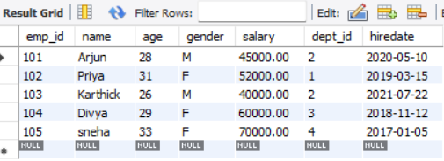
-----FIND THE YOUNGEST EMPLOYEE IN THE COMPANY----
9. SELECT *
FROM employees
WHERE age = (SELECT MIN(age) FROM employees);
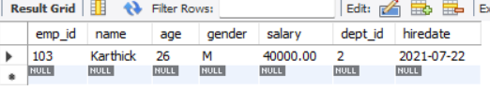

--COUNT how many employees in each department-------
10. SELECT d.dep_name, COUNT(e.emp_id) AS employee_count
FROM department d JOIN employees e ON d.dept_id = e.dept_id GROUP BY d.dep_name;
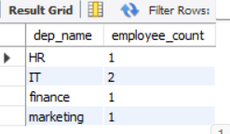
---SHOW only female employees with salary above 45000-----
11. select name,salary from employees where gender='F' and salary>45000;
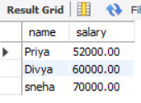

Project 1: Basic Employee Management System

Objective: Simulate a simple employee database and perform basic CRUD operations.
- create database day10_db;
- use day10_db;
- create table employees(id int primary key,name varchar(20),department varchar(20),salary decimal(10,2));
- insert into employees(id,name,department,salary)values
(1,'Alice','engineering',70000), (2,'Bob','Marketing',60000);

- select * from employees;
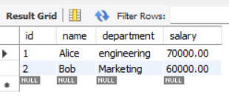
- UPDATE employees SET salary=75000 WHERE name='Alice';
- select * from employees;
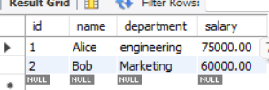
- Delete from employees where name='Bob';
- select * from employees;
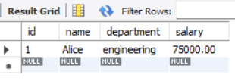

Project 2: Sales Data Querying

Objective: Query and filter sales data from a table to answer specific business questions.
- create database mini34_db;
- create table sales(order_id int primary key,product varchar(20),quantity int,price decimal(10,2),region varchar(10));

- describe sales;
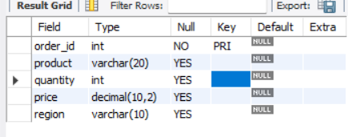
4. insert into sales(order_id,product,quantity,price,region)values(1,'A',2,500,'EAST'), (2,'B',4,1000,'SOUTH'),(3,'C',6,1500,'EAST'),
(4,'D',5,1250,'EAST'),(5,'E',3,750,'EAST'),(6,'F',2,500,'SOUTH');
- select* from sales;
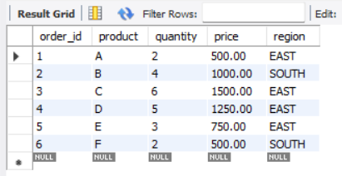
.------(Aggregation): Find the total revenue from all sales. ------
- select SUM(quantity*price) as total_revenue from sales;
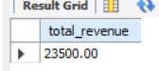
6. insert into sales(order_id,product,quantity,price,region)values(7,'A',6,250,'East'),(8,'c',7,800,'south'),(9,'F',7,2000,'East');

- select* from sales;
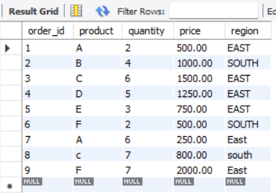

---- (Filtering and Ordering): Find all sales in the 'East' region that had a quantity greater than 5, and order them by price in descending order. --------
8.select * from sales where region='East' and quantity>5 order by price desc;
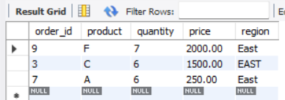
-----(Grouping): Find the average price of sales for each product -----
9.select product, avg(price) as average from sales group by product;
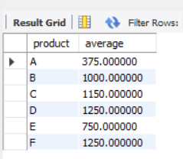

Project 3: Inventory Management

Objective: Use SQL to track and update the stock of a product
- create database mini35_db;
2. create table product(product_id int primary key,product_name varchar(50),stock int);
3. describe product;
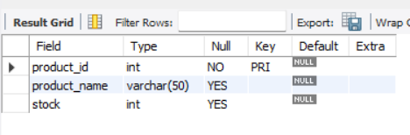
4. insert into product(product_id,product_name,stock)values(101,'productA',40),(102,'PRODUCT B',30),(103,'PRODUCT C',20), (104,'PRODUCT D',10);
------SELECT the current stack-----
5.Select * from product;
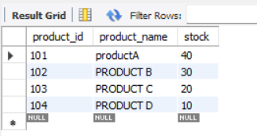
---------------update the stack after sale------

6. update product set stock=stock-7 where product_name='product B';

- select * FROM PRODUCT;
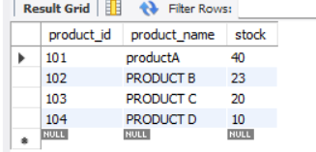

-----INSERT a new product ---------

8. INSERT into product(product_id,product_name,stock)values(105,'product E',10);
9.select * FROM product;
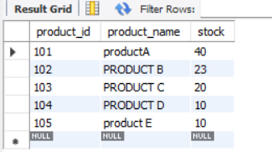

Project 4: Customer Segmentation

Objective: Find the top 5 customers by total spending

- CREATE DATABASE mini36_db;
- use mini36_db;

3. insert into customer(customer_id,customer_name,product,price)values(101,'cust01','A',200),(102,'cust02','A',300),(103,'cust01','B',350),
(104,'cust03','A',150),(105,'cust02','B',100),(106,'cust03','A',500),(107,'cust01','c',600),(108,'cust03','c',100);
4. insert into customer(customer_id,customer_name,product,price)values(109,'cust04','C',400),(110,'cust05','A',400),(111,'cust06','c',100),(112,'cust07','A',600);
5. select * from customer;
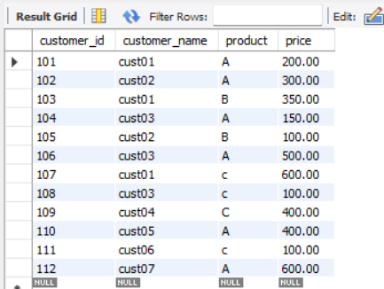

--------Use GROUP BY to sum total spending per customer ------

- select customer_name,SUM(price) as total_spend from customer group by customer_name;
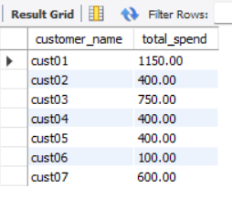

-------ORDER BY to rank them, and LIMIT (or TOP) to get the top 5. -----
8. SELECT customer_name, SUM(price) AS total_spent
FROM customer GROUP BY customer_name
ORDER BY
total_spent DESC LIMIT 5;
